

Mathematics Specialist
Unit 3

TEST 3

Student name: _______________________ Teacher name: _______________________

Time allowed for this task: 45 minutes, in class, under test conditions
Calculator-Assumed

Materials required:
Standard items: Pens (blue/black preferred), pencils (including coloured), sharpener, correction fluid/tape, eraser, ruler, highlighters, SCSA Formula Sheet.
Classpad Calculator and Scientific Calculator.
Special items: Drawing instruments, templates

Marks available: 44 marks

Task weighting: 8%

Question 1 (7 marks)

The points A and B have position vectors 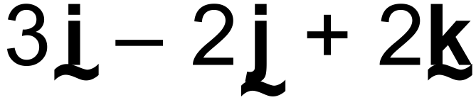 and 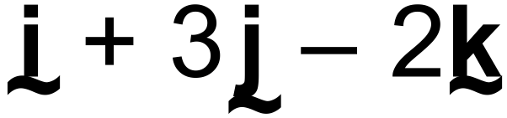 respectively.

(a) Determine a vector equation for the straight line passing through A and B (2 marks)

(b) Write your answer to (a) in its parametric equivalent and hence, or otherwise, express the Cartesian equation of the line in the form . (3 marks)

(c) Determine a unit vector parallel to the straight line in (a). (2 marks)

Question 2 (9 marks)
A plane contains the two lines 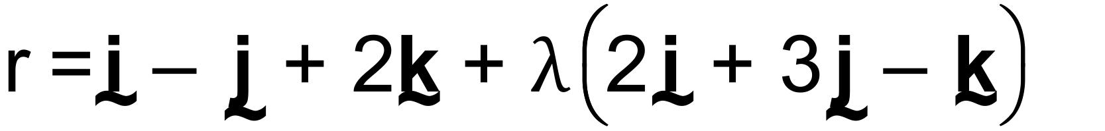 and

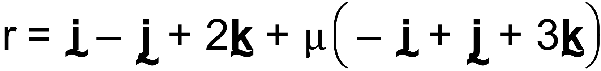

(a) Write down a vector equation of the plane . (1 mark)

(b) The point 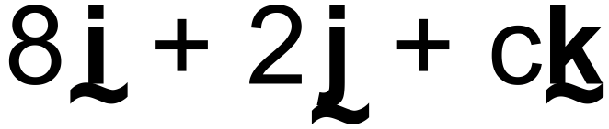 lies in the plane . Determine the value of the constant c.
(3 marks)

(c) The vector 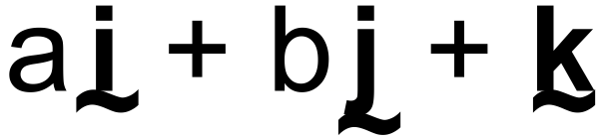 is perpendicular to the plane . Determine the values of the constants a and b. (3 marks)

(d) State the equation of the plane in the form  . (2 marks)

Question 3. (5 marks)

(a)
(i) Find the Cartesian equation of a sphere with centre (1, -2, 3) and radius 5.
(2marks)

(ii) Hence write the vector equation of this sphere. (1mark)

(b) Find the radius and centre of a sphere with the equation: (2marks)

Question 4 (9 marks)

A particle P, begins from a point 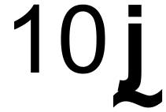 m and continues with constant velocity 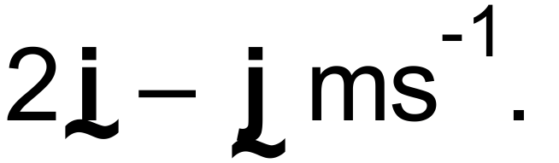
One second later another particle, starts at the point 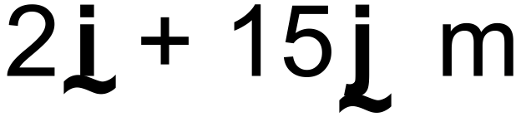 and moves with constant velocity 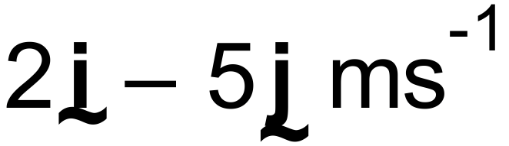 .

(a) Show that the particles collide. (5 marks)

(b) Find the Cartesian equations of their paths. (2 marks)

(c) Find the Cartesian coordinates for the point of collision. (2 marks)
Question 5 (7 marks)

In the diagram below, are midpoints of the sides of the quadrilateral.

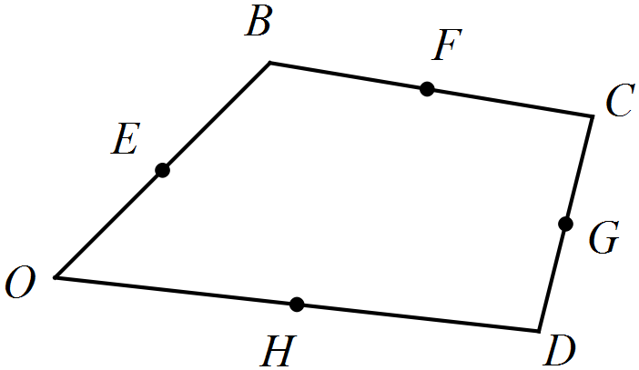

Let .

(a) Show that 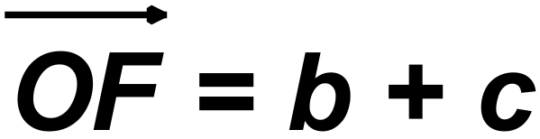 . (2 marks)

(b) Determine 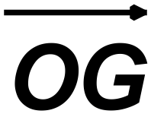 in terms of b, c, and d (2 marks)

(c) Prove that  is a parallelogram. (3 marks)

Question 6 (7 marks)

Use the vector product (cross product) to find the area of the triangle with vertices

A(-1,3,2), B(3,5,1) and C(1,6,-2)

